EXPERIMENT NO. 4: ONLINE TRAIN RESERVATION SYSTEM
AIM:
To implement an online train reservation web system supporting train searches by origin/destination stations, class-wise seat quotas, PNR generation, real-time PNR status tracking, and automated refund percentage calculation upon cancellation.
PSEUDOCODE (IN 6 SIMPLE POINTS):
Step 1: Authenticate passenger credentials and accept journey criteria: Origin, Destination, Date, and Class (1A, 2A, 3A, SL).
Step 2: Search and display list of operating trains with departure/arrival timings and real-time quota status.
Step 3: Accept passenger details (name, age, berth preference) and calculate total train fare including GST.
Step 4: Generate an authenticated 10-digit PNR number upon payment simulation and mark booking status as Confirmed or RAC.
Step 5: Provide a PNR inquiry search tool to retrieve passenger berth and coach allocation details.
Step 6: Execute ticket cancellation logic by computing refund deductions based on time remaining before departure.
SOURCE CODE:
<!DOCTYPE html>
<html lang="en">
<head>
<meta charset="UTF-8">
<title>RailYatra - Train Reservation System</title>
<style>
body { font-family: 'Segoe UI', sans-serif; margin: 0; background: #eef2f6; }
.navbar { background: #003366; color: white; padding: 15px 30px; display: flex; justify-content: space-between; }
.main { max-width: 950px; margin: 25px auto; background: white; padding: 25px; border-radius: 8px; box-shadow: 0 4px 12px rgba(0,0,0,0.08); }
.grid-inputs { display: grid; grid-template-columns: repeat(4, 1fr); gap: 12px; margin-bottom: 20px; }
input, select, button { padding: 10px; border: 1px solid #b0bec5; border-radius: 4px; box-sizing: border-box; width: 100%; }
button { background: #ff6600; color: white; border: none; font-weight: bold; cursor: pointer; }
button:hover { background: #e65c00; }
.train-item { border: 1px solid #cfd8dc; padding: 15px; border-radius: 6px; margin-bottom: 12px; display: flex; justify-content: space-between; align-items: center; }
.badge-avail { background: #e8f5e9; color: #2e7d32; padding: 4px 10px; border-radius: 4px; font-weight: bold; }
.pnr-box { background: #f0f7ff; border: 1px solid #bbdefb; padding: 18px; border-radius: 8px; margin-top: 20px; }
</style>
</head>
<body>
<div class="navbar">
<h2>National Rail Reservation Portal</h2>
<span>IRCTC Web Simulator</span>
</div>
<div class="main">
<h3>Search Trains Between Stations</h3>
<div class="grid-inputs">
<input type="text" id="srcStation" placeholder="Origin Station (e.g., MAS)">
<input type="text" id="destStation" placeholder="Destination (e.g., SBC)">
<input type="date" id="jDate">
<select id="tClass">
<option value="Sleeper (SL) - Rs. 320">Sleeper (SL) - Rs. 320</option>
<option value="AC 3 Tier (3A) - Rs. 840">AC 3 Tier (3A) - Rs. 840</option>
<option value="AC 2 Tier (2A) - Rs. 1250">AC 2 Tier (2A) - Rs. 1250</option>
</select>
</div>
<button onclick="searchTrains()">Find Available Trains</button>
<div id="trainList" style="margin-top: 20px; display: none;">
<div class="train-item">
<div>
<h4>12607 - Lalbagh Express (MAS &rarr; SBC)</h4>
<p>Dep: 06:00 AM | Arr: 11:30 AM | Runs: Daily</p>
</div>
<div>
<span class="badge-avail">Seats: Available - 42</span><br><br>
<button onclick="openBooking('12607 Lalbagh SF Exp')" style="width: auto; padding: 8px 16px;">Book Ticket</button>
</div>
</div>
</div>
<div id="bookingModal" style="display:none; margin-top: 20px; border-top: 2px solid #eceff1; padding-top: 15px;">
<h4 id="bookingTrainTitle"></h4>
<input type="text" id="pName" placeholder="Passenger Full Name" style="width: 48%; display: inline-block;">
<input type="number" id="pAge" placeholder="Age" style="width: 20%; display: inline-block;">
<select id="pBerth" style="width: 28%; display: inline-block;">
<option>Lower Berth</option><option>Middle Berth</option><option>Upper Berth</option><option>Side Lower</option>
</select><br><br>
<button onclick="confirmTrainBooking()" style="width: 200px;">Generate PNR Ticket</button>
</div>
<div id="pnrDisplay"></div>
<hr style="margin: 30px 0;">
<h3>PNR Status Inquiry & Refund Calculation</h3>
<div style="display: flex; gap: 10px;">
<input type="text" id="checkPnr" placeholder="Enter 10-digit PNR Number" style="max-width: 300px;">
<button onclick="lookupPNR()" style="width: 150px; background: #003366;">Check Status</button>
<button onclick="cancelTrainTicket()" style="width: 180px; background: #d32f2f;">Cancel & Get Refund</button>
</div>
<div id="pnrStatusResult"></div>
</div>
<script>
let pnrDatabase = {};
function searchTrains() {
document.getElementById('trainList').style.display = 'block';
}
function openBooking(tName) {
document.getElementById('bookingModal').style.display = 'block';
document.getElementById('bookingTrainTitle').innerText = 'Booking for: ' + tName;
}
function confirmTrainBooking() {
let name = document.getElementById('pName').value.trim();
let age = document.getElementById('pAge').value;
let cls = document.getElementById('tClass').value;
if(!name || !age) return alert('Enter passenger details');
let fare = cls.includes('1250') ? 1250 : (cls.includes('840') ? 840 : 320);
let pnr = Math.floor(1000000000 + Math.random() * 9000000000).toString();
pnrDatabase[pnr] = { name, age, class: cls, fare, status: 'CONFIRMED (Coach B2, Berth 23)', date: document.getElementById('jDate').value };
document.getElementById('pnrDisplay').innerHTML = `
<div class="pnr-box">
<h3 style="color:#003366; margin-top:0;">E-Ticket Generated Successfully!</h3>
<p><b>PNR Number:</b> <span style="font-size: 18px; color: #ff6600; font-weight: bold;">${pnr}</span></p>
<p><b>Passenger:</b> ${name} (${age} yrs) | <b>Status:</b> ${pnrDatabase[pnr].status}</p>
<p><b>Class:</b> ${cls} | <b>Fare Paid:</b> Rs. ${fare}</p>
</div>`;
}
function lookupPNR() {
let pnr = document.getElementById('checkPnr').value.trim();
if(pnrDatabase[pnr]) {
let rec = pnrDatabase[pnr];
document.getElementById('pnrStatusResult').innerHTML = `<p style="color:#003366; font-weight:bold;">PNR ${pnr}: ${rec.name} | Class: ${rec.class} | Current Status: ${rec.status}</p>`;
} else {
document.getElementById('pnrStatusResult').innerHTML = `<p style="color:red;">Invalid or Unregistered PNR number.</p>`;
}
}
function cancelTrainTicket() {
let pnr = document.getElementById('checkPnr').value.trim();
if(!pnrDatabase[pnr]) return alert('PNR not found');
let fare = pnrDatabase[pnr].fare;
let refundPct = 75; // Cancellation charge 25%, refund 75%
let refundAmount = (fare * refundPct) / 100;
delete pnrDatabase[pnr];
document.getElementById('pnrStatusResult').innerHTML = `<div style="background:#ffebee; color:#c62828; padding:10px; border-radius:4px; font-weight:bold;">Ticket Cancelled! Refund of Rs. ${refundAmount} (${refundPct}% of Rs. ${fare}) initiated to customer account.</div>`;
}
</script>
</body>
</html>
Output:
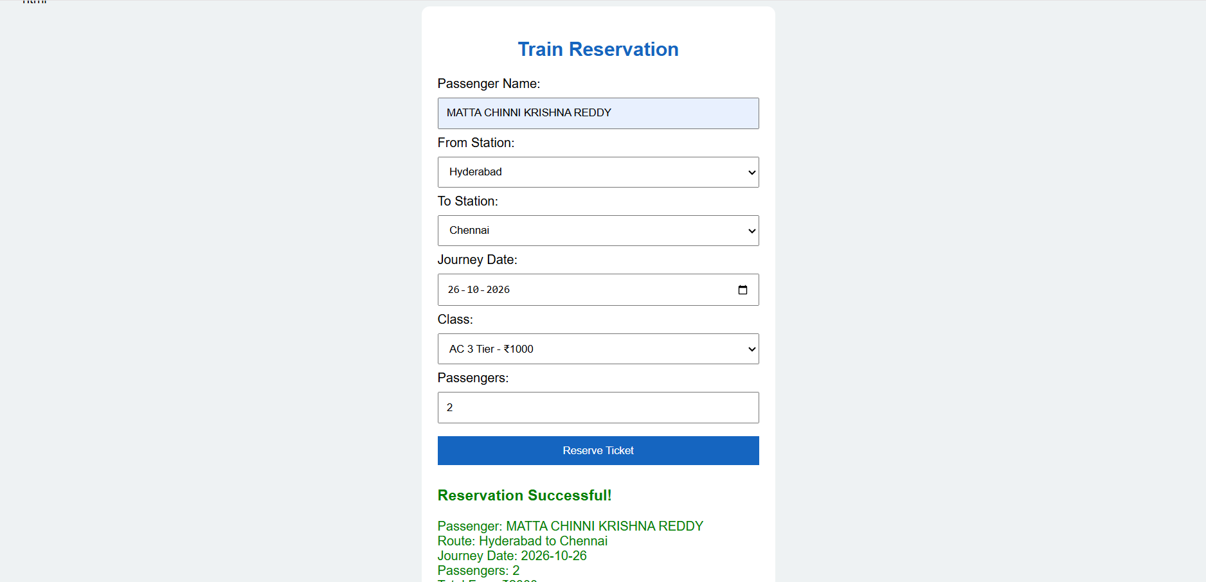
RESULT:
Thus, the online train reservation system was successfully built and tested, featuring multi-class train search, PNR issuance, live status enquiry, and automated cancellation refund calculation.

